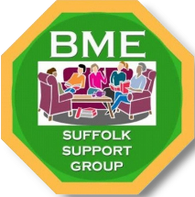
Become a Friend of BME Suffolk Support Group
Registration Number: 1335694
Stronger Together (Talk, Listen, Understand, Empower)
Thank you for supporting our work in building stronger and more inclusive communities.
Become a friend of BME Suffolk with £25 per annual or £3 per month
Full Name
____________________________________________
Address
____________________________________________
Email
____________________________________________
Telephone
____________________________________________
Signature
_____________________ Date ________________
By signing this form, I confirm that I wish to become a Friend of BME Suffolk Support Group and support the work and projects of the organisation. I also agree to receive occasional updates about BME Suffolk Support Group's activities, events, and opportunities to get involved.

